ASSIGNMENT –2

CREATE , UPDATE , DELETE COMMANDS IN MYSQL

CODE:

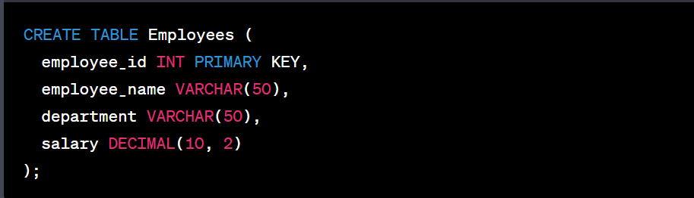

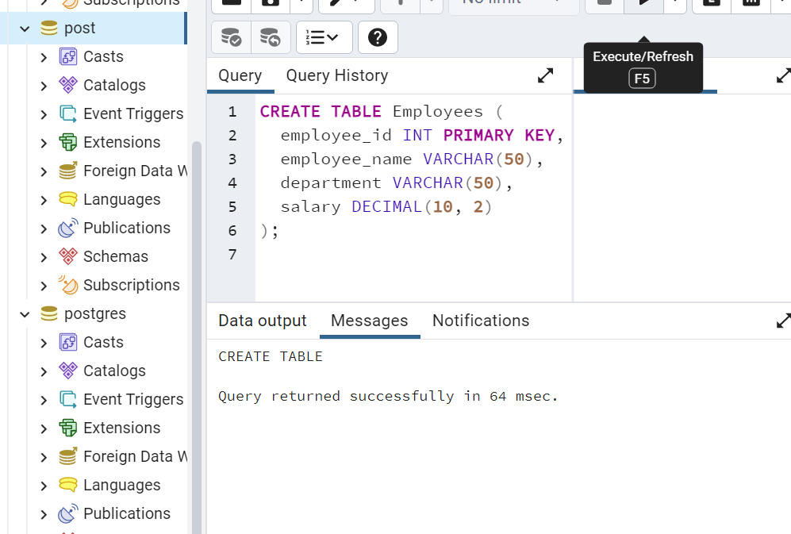



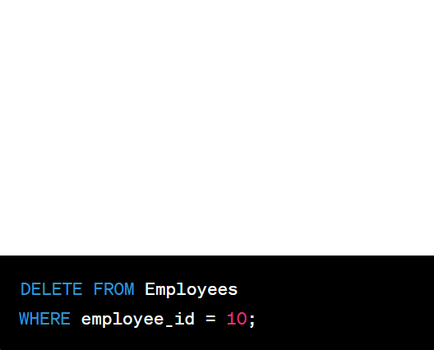

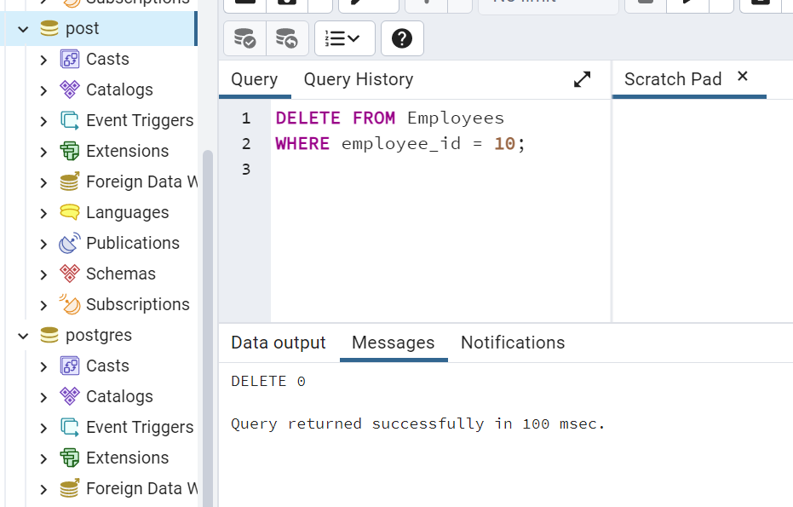

CREATE TABLES AND PERFORM JOINS IN MYSQL

CODE:

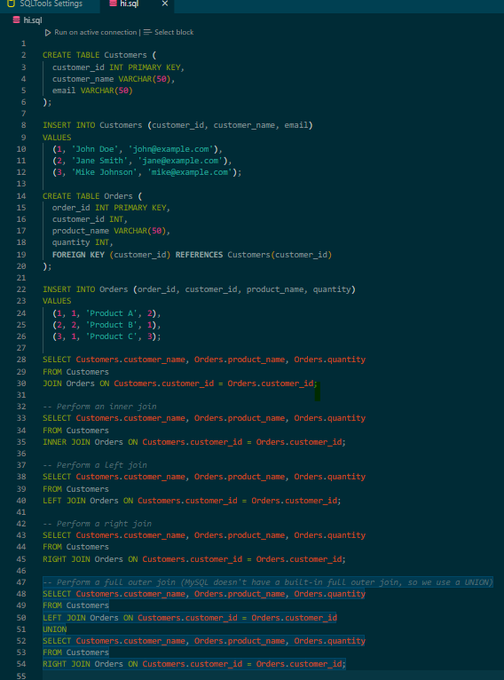

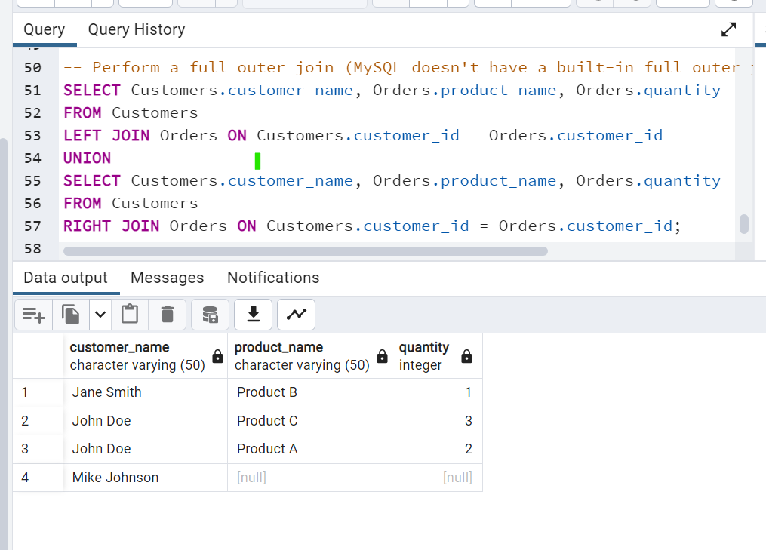

CREATE , UPDATE, DELETE COMMANDS IN MONGO

